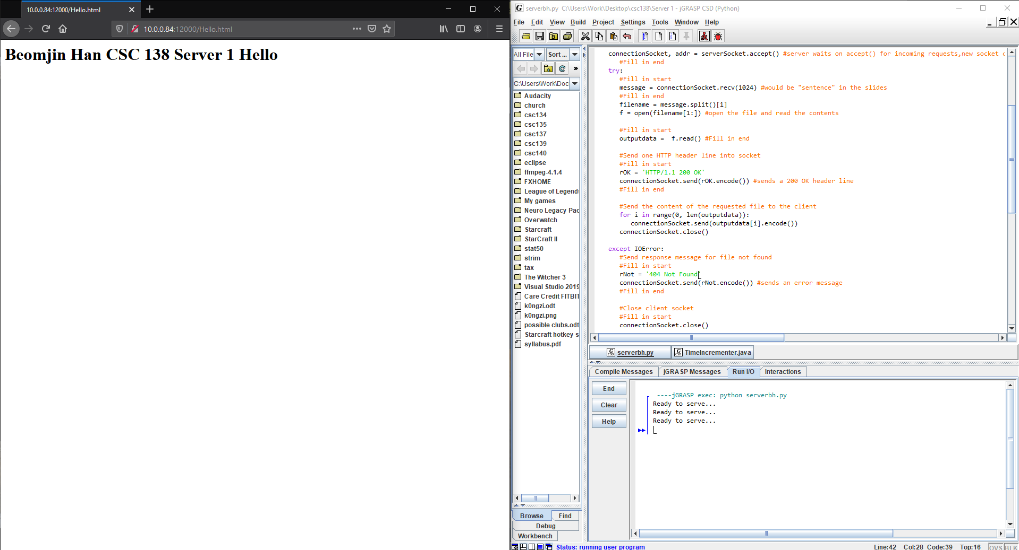
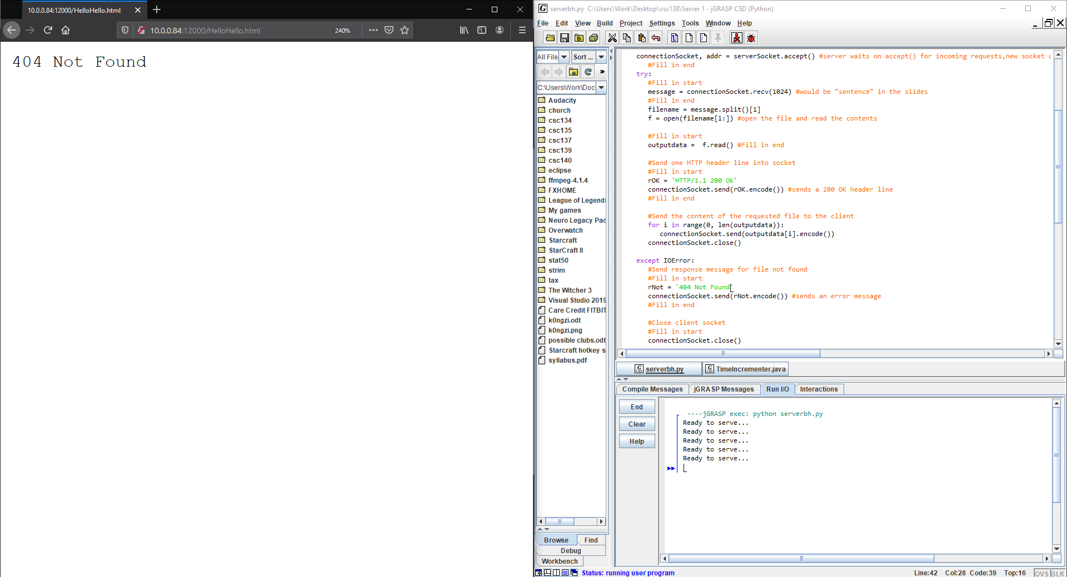
Beomjin Han
CSC 138-03
Webserver Socket 1

Below are the screenshots for successfully reading the html file and wrong filename in the address.

#import socket module
from socket import *
serverSocket = socket(AF_INET, SOCK_STREAM)
#Fill in start
serverPort = 12000 #setting port number to 12000
serverSocket.bind(('',serverPort)) #binding the server to the port
serverSocket.listen(1) # server begins listening for incoming TCP requests
#Fill in end
while True:
#Establish the connection
print ('Ready to serve...')
#Fill in start
connectionSocket, addr = serverSocket.accept() #server waits on accept() for incoming requests,new socket created on return
#Fill in end
try:
#Fill in start
message = connectionSocket.recv(1024) #would be "sentence" in the slides
#Fill in end
filename = message.split()[1]
f = open(filename[1:]) #open the file and read the contents
#Fill in start
outputdata = f.read() #Fill in end
#Send one HTTP header line into socket
#Fill in start
rOK = 'HTTP/1.1 200 OK'
connectionSocket.send(rOK.encode()) #sends a 200 OK header line
#Fill in end
#Send the content of the requested file to the client
for i in range(0, len(outputdata)):
connectionSocket.send(outputdata[i].encode())
connectionSocket.close()
except IOError:
#Send response message for file not found
#Fill in start
rNot = '404 Not Found'
connectionSocket.send(rNot.encode()) #sends an error message
#Fill in end
#Close client socket
#Fill in start
connectionSocket.close()
#Fill in end
serverSocket.close()

